Vehicle gates – from inside

To open the gates
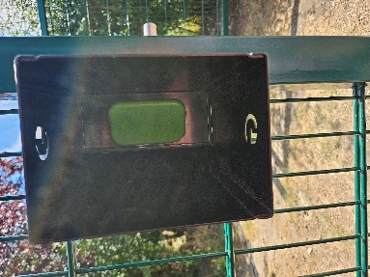
1. Park at the Stop sign so there is room for the gates to open.
2. Start with the right gate. Twist rod, lift and twist back to hold.
3. Reach into the black metal box. Push the right hand side of the green plate and pull it from the left.
4. Open both gates fully using the rods on each side to hold them in place while you drive through.
5. Close the gate behind you.

Note – the gates need to be secured while you are driving through as the wind can blow them closed. BWGC is not responsible for any damage to your vehicle caused by failure to secure the gates.

Gates should be closed at all times except on weekends when The Shop is open.

Vehicle gates – from inside

To close from inside
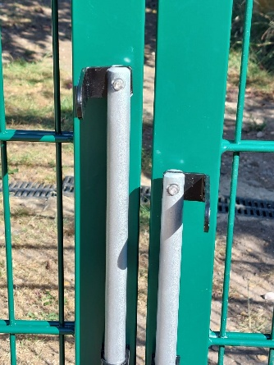
1. Start at right gate. Twist rod, lift and twist back to hold.

2. Close gate, drop rod into central hole. Make sure it is firmly secured.

3. Left gate - twist rod, lift and twist back to hold.

4. Pull gate shut – DO NOT drop the left hand rod into hole. The rods should be at different heights – see picture.

Gates should be closed at all times except on weekends when The Shop is open.

